Chapter 7, Solution 65.

Since 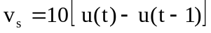, this is the same as saying that a 10 V source is turned on at t = 0 and a -10 V source is turned on later at t = 1. This is shown in the figure below.
v_{s}
-10
t
1
10
For 0 < t < 1, 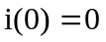, 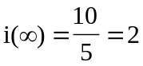
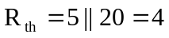, 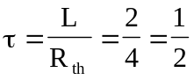
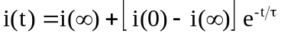
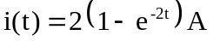
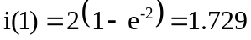

For t > 1, 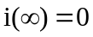 since 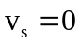
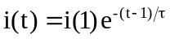
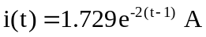

Thus,
